Soil & Water Conservation Districts

NEW MEXICO SOIL & WATER CONSERVATION DISTRICT ACT

The New Mexico’s Soil and Water Conservation District Act, Chapter 73, Article 20, Sections 25-48 of the New Mexico Statutes Annotated (NMSA) 1978 may be cited as the Soil and Water
Conservation District Act. Press Ctrl+click as directed to access this link.
http://public.nmcompcomm.us/nmpublic/gateway.dll/?f=templates&fn=default.htm

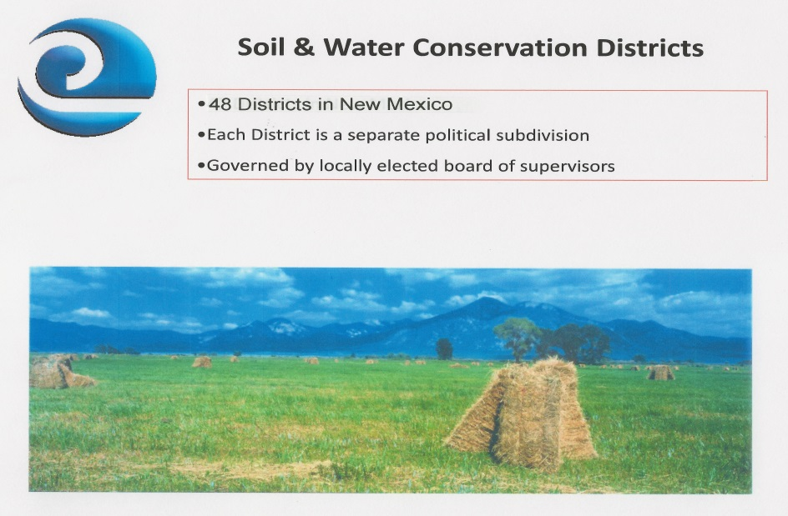
SWCD’S are defined under the State SWCD Law as “a governmental subdivision of the state, a public body politic and corporate.” As such, SWCD’s have the responsibility of making available technical, educational, and where possible, financial assistance, to meet the natural resource conservation needs of the public within their SWCD areas.

SOIL AND WATER CONSERVATION COMMISSION (SWCC) was also established under the SWCD District Act to advise and assist the state agency (NMDA) in the following activities:
1. Assist SWCD’s in the development of SWCD programs;
2. Provide information for supervisors to facilitate exchange of information among
SWCD’s;
3. Promote cooperation and coordination between SWCD’s and programs;
4. Secure and maintain cooperation and assistance of state and federal agencies
in natural resources conservation and development;
5. Disseminate information regarding SWCD activities and programs;
6. Encourage and render assistance for SWCD activities and encourage the formation
of new districts where desirable;
7. Also – advise NMDA and Board of Regents concerning matters that may have
significant impacts or affects soil and water conservation;
8. Promulgate rules to carry out provisions of the SWCD Act.
SWCC Membership
1. Seven members appointed by the Governor to serve at the pleasure of the Governor.
2. Six appointed members shall be SWCD supervisors from each of the six SWCD regions
in New Mexico. One appointed member shall be selected at large.
3. Three candidates for the SWCC are nominated from each of the six SWCD regions
whose names are presented to the Governor by the President of the New Mexico
Association of Conservation Districts (NMACD).
4. Five ex-officio members to serve without vote and shall include: Governor or his/her
designee; Associate Director of the Cooperative Extension Service or his/her designee;
Associate Director of the New Mexico Agriculture Experiment Station or his/her designee;
the State Conservationist of the Natural Resources Conservation Service (USDA); and
the President of the New Mexico Association of Conservation Districts.

NEW MEXICO DEPARTMENT OF AGRICULTURE (NMDA)

The NMDA provides oversight and administrative guidance to the SWCD’s, and in addition, to the eight duties described under the SWCC:
1. Assigns staff to assist local SWCD Boards with planning and development of
programs and projects and administrative matters;
2. Provides Information, promotes cooperation between SWCD’s;
3. Secure cooperation and assistance of state and federal agencies;
4. Renders aid and assistance to SWCD’s within budget limitations.

SOIL AND WATER CONSERVATION DISTRICTS’ BOARDS OF SUPERVISORS [NMDA Supervisor Handbook]

Each of the SWCDs has a governing body that is comprised of the following:
- Five publically elected supervisors who are residents of their SWCD;
- Four of the elected supervisors must be landowners within defined geographical areas of
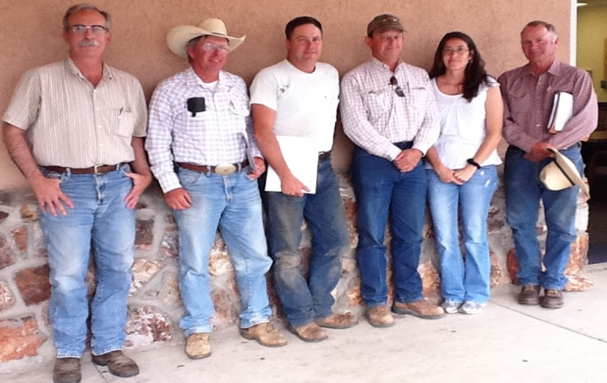
their district;
3. One elected supervisor is a
designated supervisor-at-large
and does not have to be a
landowner.
4. Supervisors are elected to serve
terms of four years that are
staggered so that not all five
positions come up for election
at the same time.
5. Two additional supervisors may
be appointed by the SWCC;
6. As soon as is practical after each
SWCD election, the new Board
shall select a chairman to serve Grant SWCD Board of Supervisors
at the pleasure of the supervisors.

Please note that no person convicted of a felonious or infamous crime, unless such person has been pardoned or restored to political rights, shall be qualified to be elected or appointed to any public office in this state [Public Officers & Employees, Chapter 10-1-2 NMSA 1978].

Chapter 10-1-4 of this act also lists six causes for which an officer (county, precinct, district, city, town or village) may be removed from office.

Details of holding a supervisor election can be found in Chapter 13 of the NMDA District Operations Handbook. A short summary of election procedures is as follows:

Elections for positions 1-5 are held in odd-numbered years; Positions 6-7 are appointed
positions. Positions 1, 2 and 5 are up for election in the same year; positions 3-4 are up for
election two years later;
Elections are on the first Tuesday in May of odd-numbered years;
Eligible voters must have registered at least 32 days prior to the election with a residence
of record within SWCD boundaries;
SWCD’s must notify the county clerks within their district boundaries by January 1 preceding
the election;
SWCD’s inform county clerk: SWCD boundary description; SWCD boundary map; election date;
official election time; and copy of supervisor election rules;
Election officials include:
- (a) election superintendent who can be a board member not up for election,
(b) can be an employee, or
(c) anyone qualified for the position;
- canvassing board consisting of at least three members:
(a) land owner in SWCD who is not a supervisor,
(b) employee of SWCD,

(c) SWCD supervisor not up for election, or
(d) locally-elected official or designee);
- at least two polling officials at each polling location one of whom cannot be a board
member, an employee of SWCD, or immediate family member.
SWCD’s must make provisions for absentee voting.
SWCD’s must publish two notices of election in the newspaper, first one 51-65 days
prior to election, second one 23-37 days prior to election.

